**Label images**

**Create a new custom model**

Begin by going to [Vision Studio](https://portal.vision.cognitive.azure.com/) and selecting the **Image analysis** tab. Then select the **Customize models** tile.

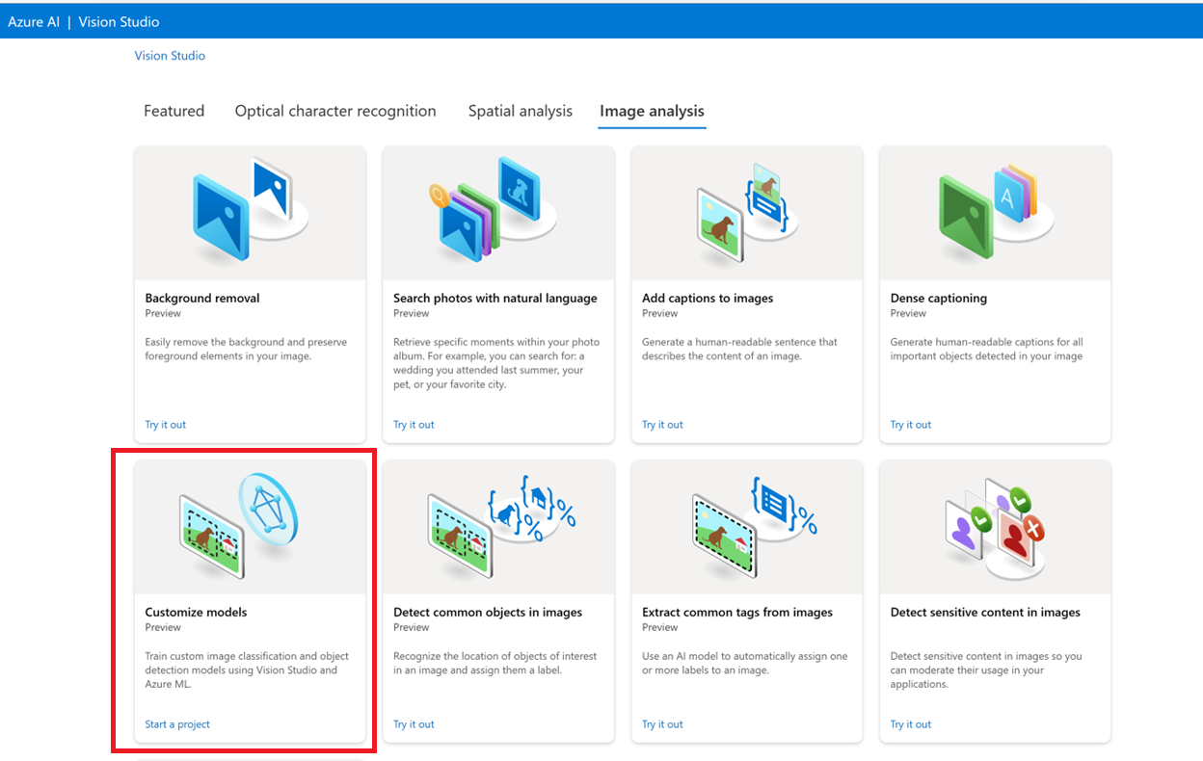

Then, sign in with your Azure account and select your Vision resource. If you don't have one, you can create one from this screen.

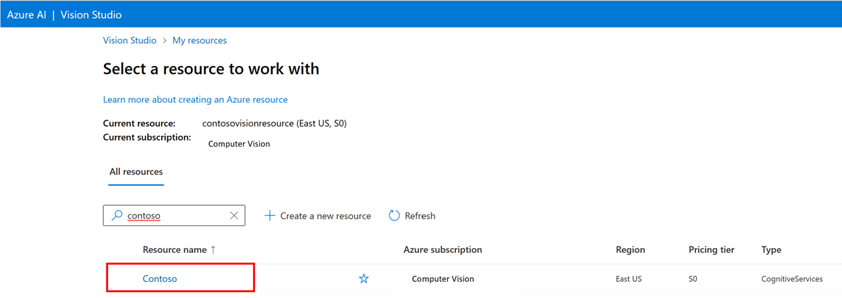

**Prepare training images**

You need to upload your training images to an Azure Blob Storage container. Go to your storage resource in the Azure portal and navigate to the **Storage browser** tab. Here you can create a blob container and upload your images. Put them all at the root of the container.

**Add a dataset**

To train a custom model, you need to associate it with a **Dataset** where you provide images and their label information as training data. In Vision Studio, select the **Datasets** tab to view your datasets.

To create a new dataset, select **add new dataset**. In the popup window, enter a name and select a dataset type for your use case. **Image classification** models apply content labels to the entire image, while **Object detection** models apply object labels to specific locations in the image. **Product recognition** models are a subcategory of object detection models that are optimized for detecting retail products.

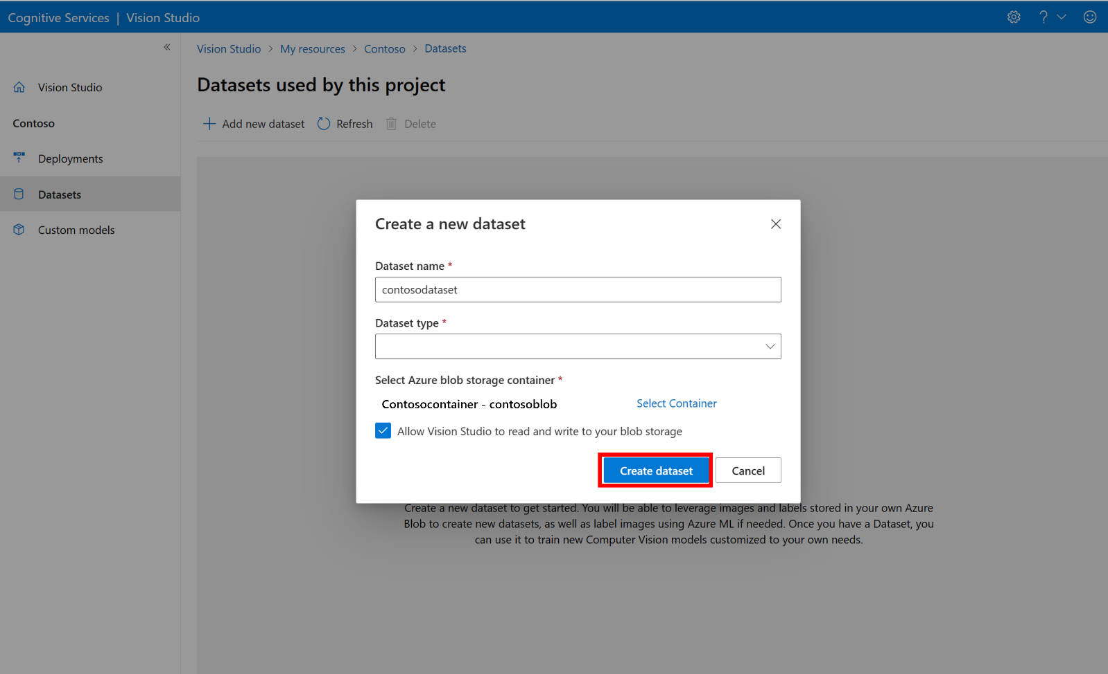

Then, select the container from the Azure Blob Storage account where you stored the training images. Check the box to allow Vision Studio to read and write to the blob storage container. This is a necessary step to import labeled data. Create the dataset.

**Create an Azure Machine Learning labeling project**

You need a COCO file to convey the labeling information. An easy way to generate a COCO file is to create an Azure Machine Learning project, which comes with a data-labeling workflow.

In the dataset details page, select **Add a new Data Labeling project**. Name it and select **Create a new workspace**. That opens a new Azure portal tab where you can create the Azure Machine Learning project.

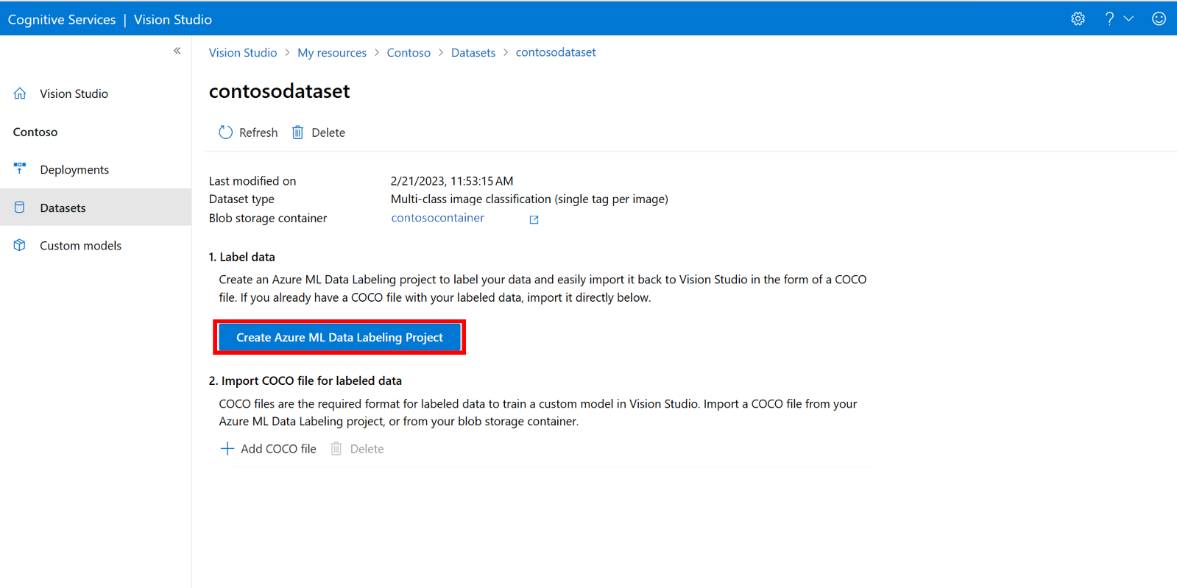

Once the Azure Machine Learning project is created, return to the Vision Studio tab and select it under **Workspace**. The Azure Machine Learning portal will then open in a new browser tab.

**Create labels**

To start labeling, follow the **Please add label classes** prompt to add label classes.

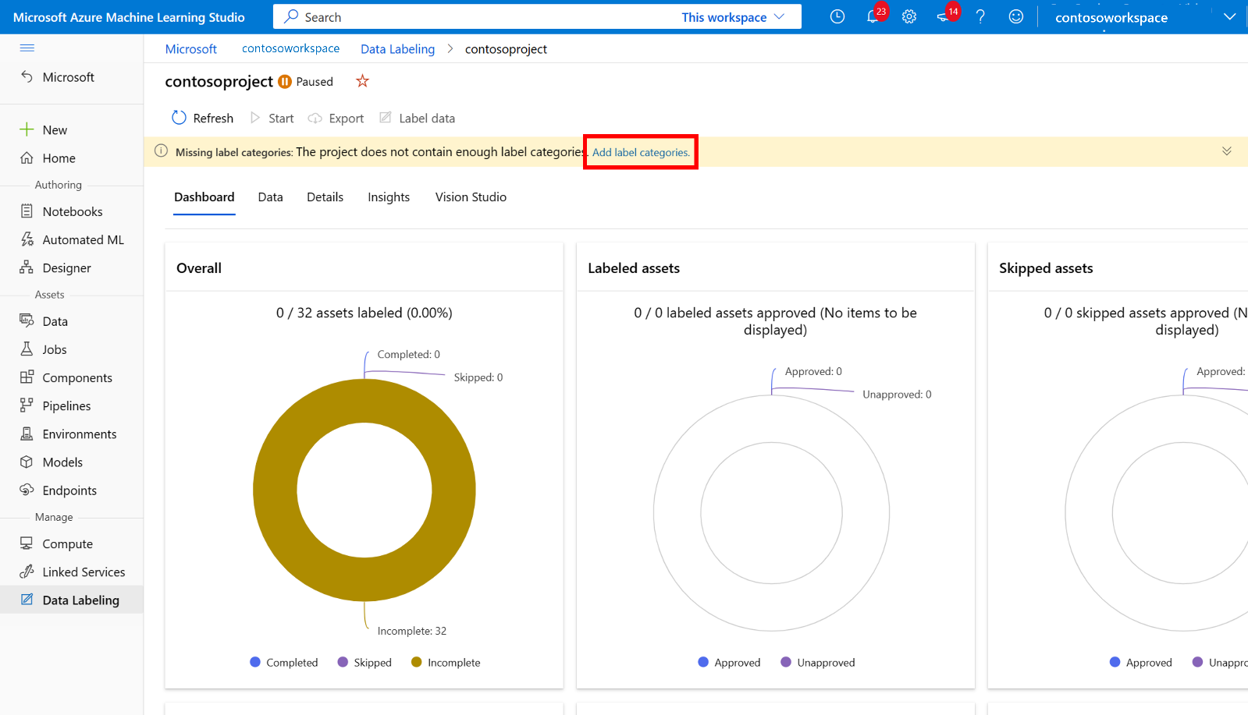

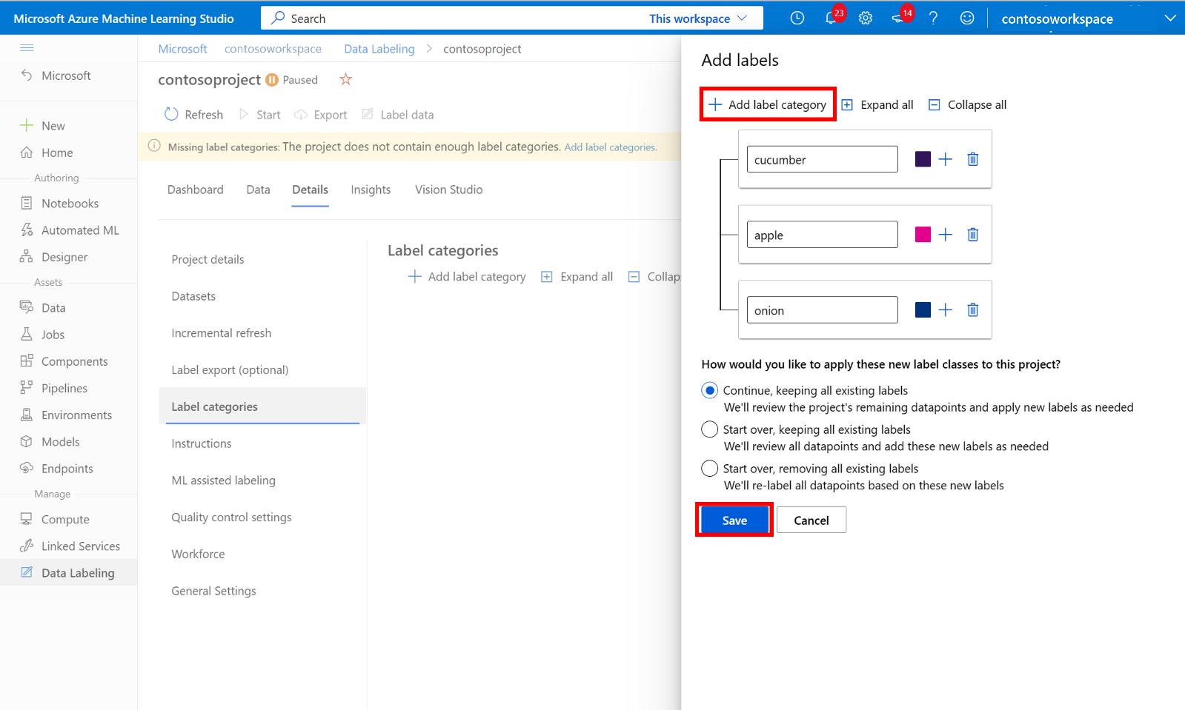

After you add all the class labels, save them, select **Start** on the project, and then select **Label data** at the top.

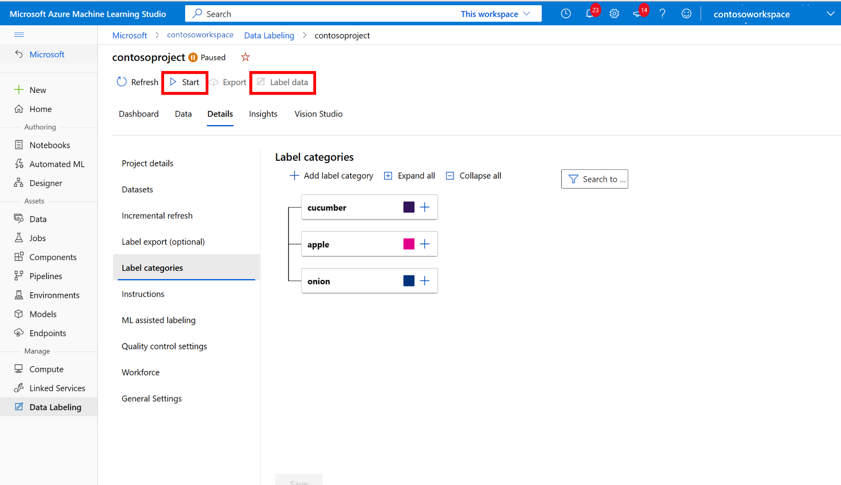

**Manually label training data**

Choose **Start labeling** and follow the prompts to label all of your images. When you're finished, return to the Vision Studio tab in your browser.

Now select **Add COCO file**, then select **Import COCO file from an Azure ML Data Labeling project**. This imports the labeled data from Azure Machine Learning.

The COCO file you created is now stored in the Azure Storage container that you linked to this project. You can now import it into the model customization workflow. Select it from the drop-down list. Once the COCO file is imported into the dataset, the dataset can be used for training a model.

**Note**

If you have a ready-made COCO file you want to import, go to the **Datasets** tab and select **Add COCO files to this dataset**. You can choose to add a specific COCO file from a blob storage account or import from the Azure Machine Learning labeling project.

Currently, Microsoft is addressing an issue that causes COCO file import to fail with large datasets when initiated in Vision Studio. To train using a large dataset, it's recommended to use the REST API instead.

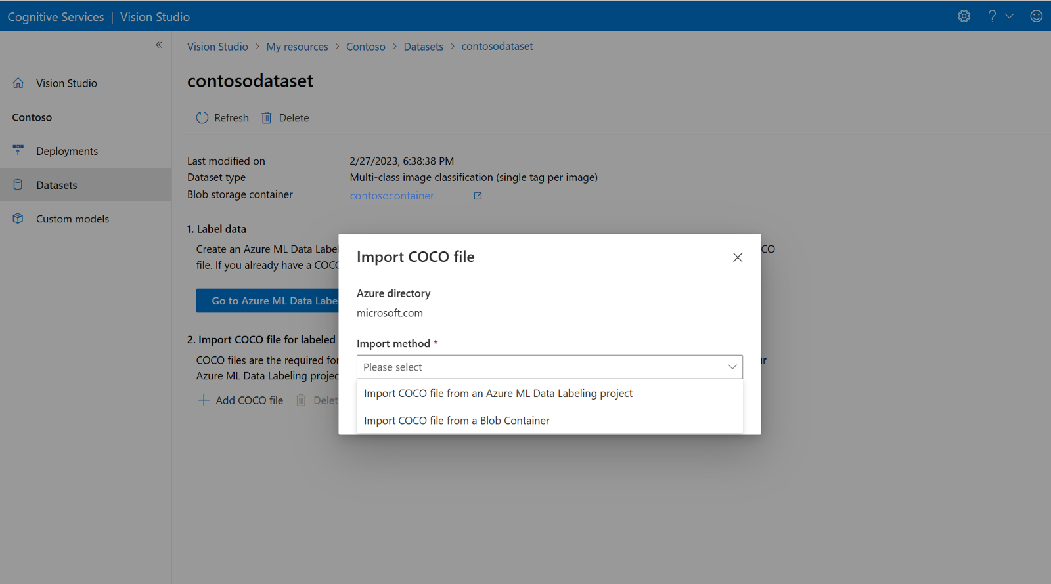

**About COCO files**

COCO files are JSON files with specific required fields: "images", "annotations", and "categories". A sample COCO file will look like this:

**COCO file field reference**

If you're generating your own COCO file from scratch, make sure all the required fields are filled with the correct details. The following tables describe each field in a COCO file:

**"images"**

The value for absolute_url can be found in your blob container's properties:

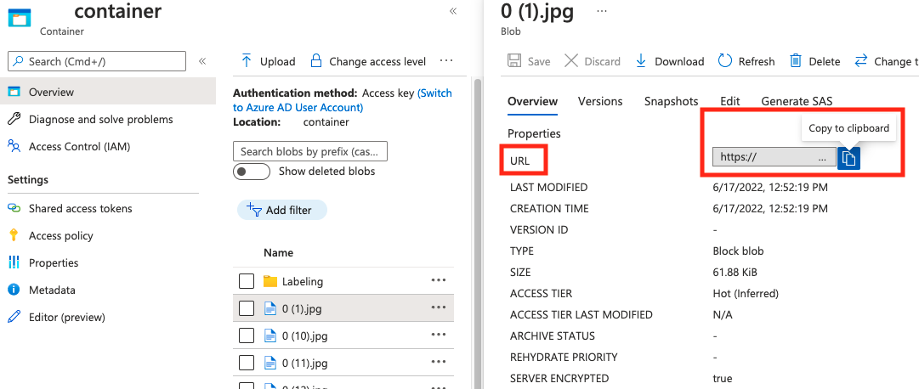

**"annotations"**

**"categories"**

